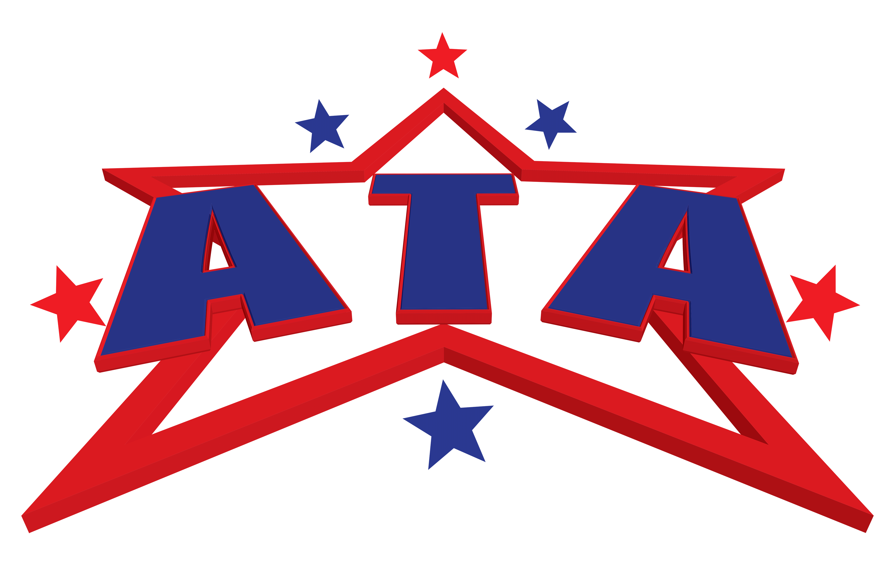 **American** Tumbling **Academy**

Agreement and Waiver:

I willingly agree to comply with the stated and customary terms, rules, and conditions for participation. I represent that I am the parent or legal guardian of the participant(s) named below, or I have obtained permission from the parent/legal guardian of the participant(s) named below to execute this agreement on their behalf. I agree that the participant(s) named below, and I will comply with all stated and customary terms, posted safety signs, rules, and verbal instructions as conditions for participation in any party and/or program at American Tumbling Academy & Preschool. I am aware that there are inherent risks associated with participation in any or all programs, parties, and/or participation in and on the play area and inflatable equipment, tumbling equipment, Cheer practices, and all rentals. I, on behalf of myself and the participant(s) named below, knowingly, and freely assume all such risks, both known and unknown, including those that may arise out of the negligence of American Tumbling Academy & Preschool and their affiliates, officers, members, agents, employees and/or other participants. I, on behalf of myself and the participant(s) named below, my heirs and assigns, next of kin, and all others acting on my or the participant’s behalf , hereby release and hold harmless American Tumbling Academy & Preschool and their affiliates, officers, members, agents, employees, other participants, and sponsoring agencies from any and all liability, loss, damage, costs (including medical expenses and attorney’s fees), claims and/or causes of action, including but not limited to all bodily injuries, arising out of the participation in the programs and activities referred to herein, including as a result of negligence. I understand the staff of American Tumbling Academy & Preschool Corporation are not physicians or medical practitioners of any kind. I hereby authorize American Tumbling Academy & Preschool Corporation to render first aid to the participant(s) listed below in the event of any injury and if deemed necessary to call for an ambulance to have the participant(s) taken to the nearest hospital, the costs of which I agree to pay. I hereby grant and convey unto American Tumbling Academy & Preschool all right, title, and interest in any and all photographic images and video or audio recordings made by American Tumbling Academy & Preschool during my activities with American Tumbling Academy & Preschool, including, but not limited to, any royalties, proceeds, or other benefits derived from such photographs or recordings and consent to the unrestricted use by American Tumbling Academy & Preschool of said images and recordings. By signing below, I agree to the above conditions, should I decide to participate.

**FOR ATA TUMBLING CUSTOMERS ONLY**

Participant Name:___________________________________Date of Birth:_____________ Age________ Parents/Guardians Cell Phone _____________________________ Address: _____________________________ City___________________ State________ Zip_________

Email: ___________________________________________________________________________ Emergency Contact___________________________Relationship___________Phone_______________ (Other than Yourself) Parent/Guardian/Participant Signature: _______________________________ Date: ___________________ Parent/Guardian

Participant Printed Name: __________________ Class day _____________Time________